DATABASE SYSTEMS ENGINEERING AND DISTRIBUTED BACKEND DEVELOPMENT
Practical Exercise 1 – Student Management REST API
Project Structure:

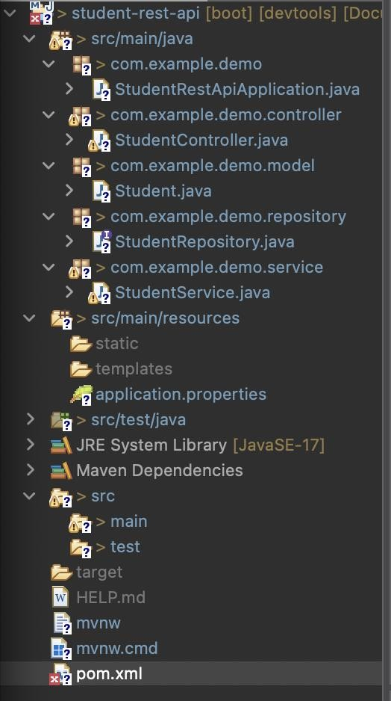
MySQL Server:
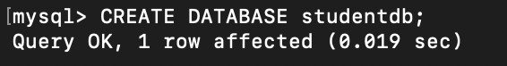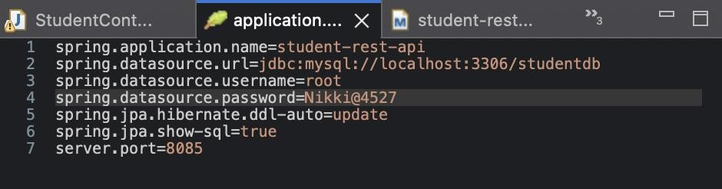

Postman:
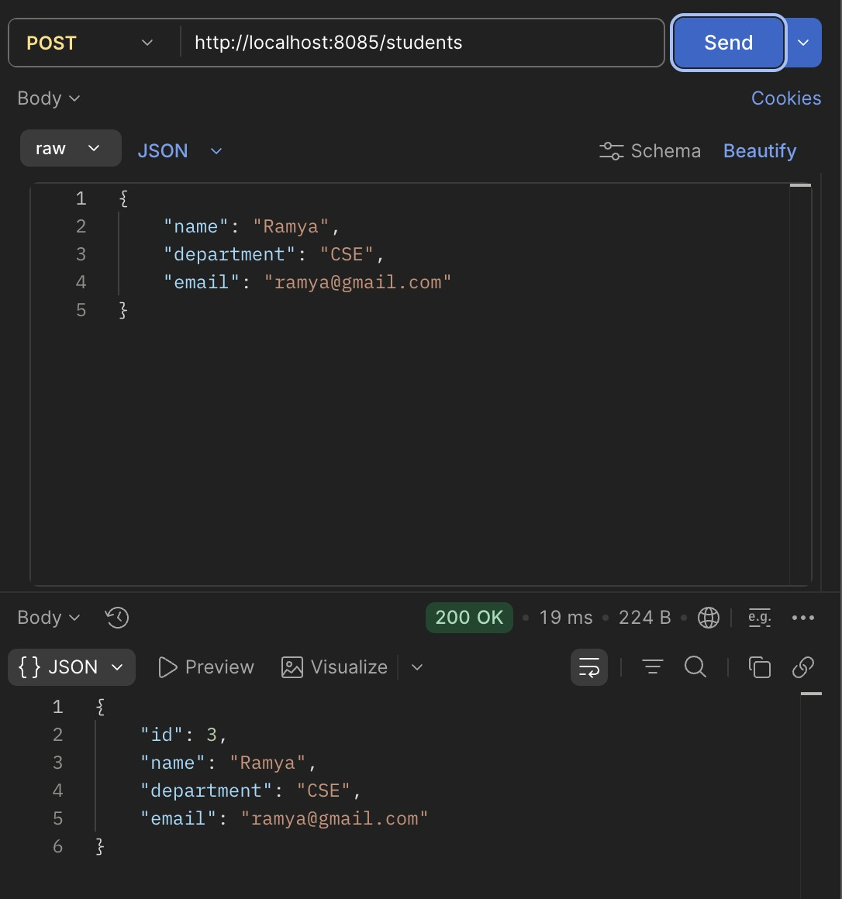
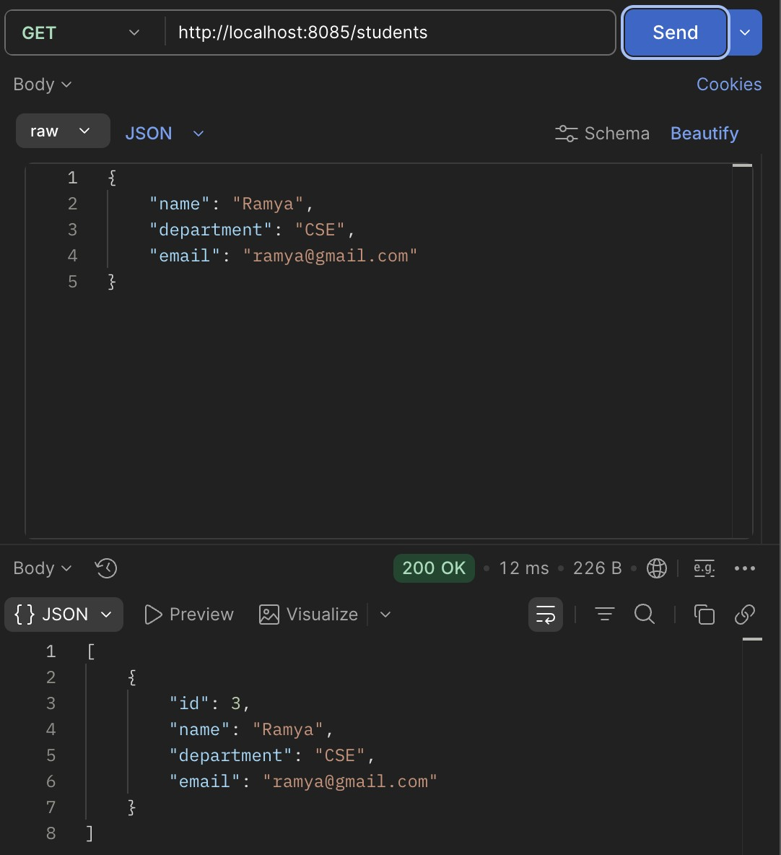

Test it with MySQL Server:
